

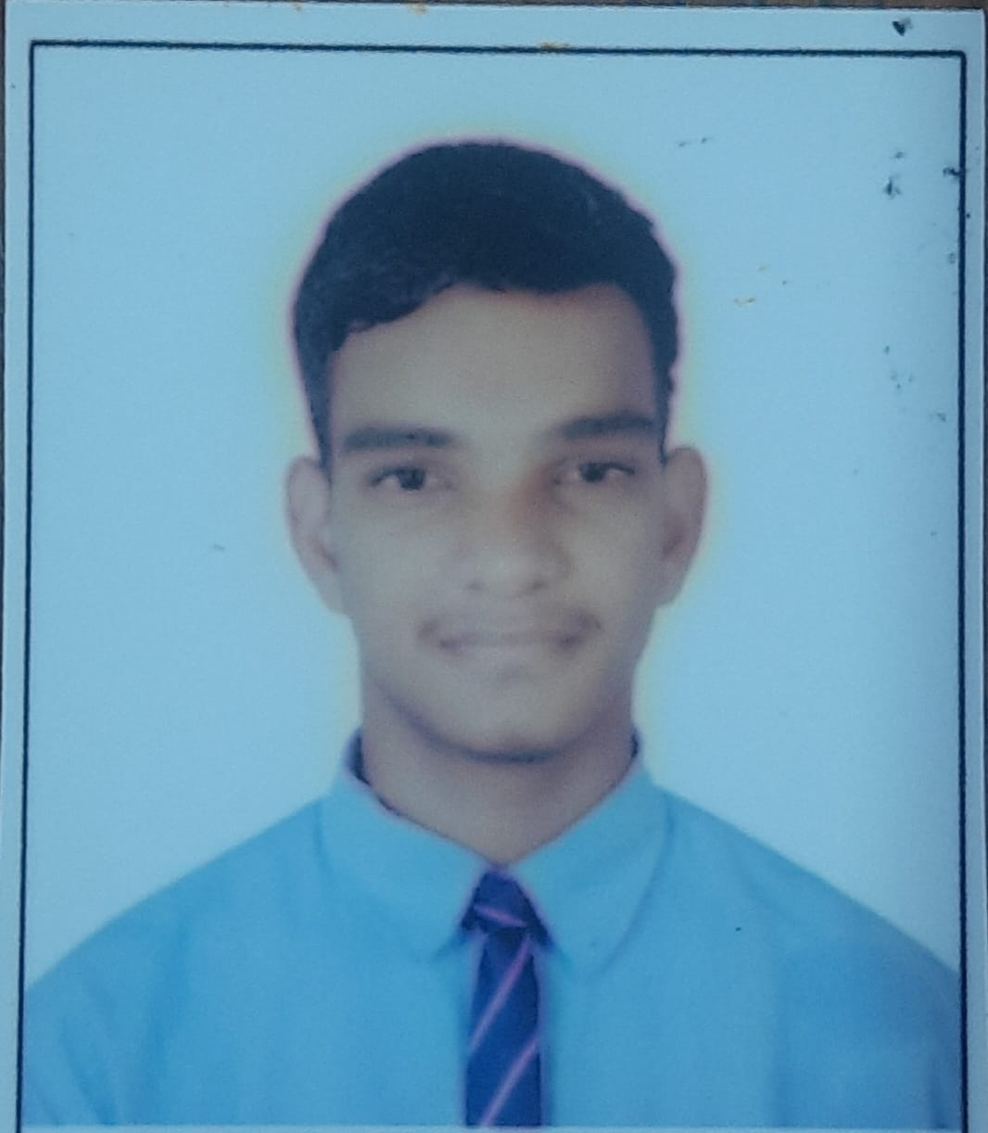

# CURRICULUM VITAE

**Degree - Integrated - BTech**

# Specialization – Electronics and Telecommunication Engineering (AIML)

|  |  |
| --- | --- |
| **Full Name :** | **Dhruv Sunil Godase** |
| **Email ID :** | **dhruvgodase7@gmail.com** |
| **Contact No. :** | **+918928455728** |

**Career Objective:**

Seeking a challenging position in a reputed organization where I can learn new skills, expand my knowledge, and leverage my learnings. To get an opportunity where I can make the best of my potential and contribute to the organization's growth & my growth.

**Academia:**

|  |  |  |  |
| --- | --- | --- | --- |
| **Course** | **Board / University / Institute** | **Year of Passing** | **Percentage / CGPA** |
| CBSE | R.N. Podar School Mumbai | 2020-21 | 87.65% |

**Additional Skill Sets / Certifications:**

* Basics of Python programming
* Basics of C++ Programming
* Basics of Machine Learning
* Basic training in PLCs
* Basic knowledge of Graphical Design
* Knowledge in Photo Editing
* 3rd prize in NCO Olympiad at School level.

**Achievements:**

* Played for School cricket team from 8th to 10th grade.

**Extra-Curricular Activities:**

* Active in sports (Cricket & Badminton).
* Participating in Aarohan (MITWPU college cultural fest) in the PR department.

**Personal Qualities:**

* Curious For Innovation.
* Problem Solving Skillset.
* Dedicated towards work
* Adaptive to any environment
* Can handle Pressure Situations
* Fast Learning Ability

**Personal Information:**

* Date of Birth : 25/08/2005
* Languages Known : English, Hindi, Marathi, Basic French
* Hobbies : Gaming, Cricket, BasketBall, Photography
* Address : Cosmos, Magarpatta City, Hadapsar, Pune, 411013.

**Declaration:**

I confirm that the information provided by me is true to the best of my knowledge and belief.

Place:

***Dhruv Godase***

Date: 9/12/2024 Signature